

Improving JB Platform Documentation
Personal Brand, Content Ecosystem, and System Distribution Platform

Team Members
Jordan Burr

May 22nd, 2026
Version 2.0

Table of Contents

I.Introduction

  - Purpose
The purpose of this document is to provide a well-organized overview of the Improving JB platform, a personal development ecosystem designed to help young adults build discipline through systems rather than just motivation. The platform combines educational content, downloadable programs, AI-assisted website navigation, email communication, and future community features into one web application.
This document outlines the platform's objectives, architecture, development process, technical implementation, feature set, analytics strategy, and a roadmap for the future. It serves as both a technical reference and a product overview for recruiters, collaborators, and individuals interested in understanding the behind the scenes of the Improving JB ecosystem.

  - Platform Overview
Improving JB began as a YouTube channel focused on helping people get their life back together using long-term self-improvement. As the audience and library content expanded, the need for a centralized platform became apparent.
The website was developed to serve as the primary hub for the ecosystem by allowing visitors to:
• Learn more about the Improving JB philosophy
• Access systems and programs
• Explore YouTube content
• Interact with an AI-powered website guide
• Subscribe to updates through the newsletter
• Participate in future community initiatives
Rather than functioning as a traditional portfolio website, the platform was designed as a product ecosystem that connects content, systems, and user engagement into one experience.

  - Project Scope
The scope of Version 2 of the platform focuses on improving user experience, increasing engagement, and creating measurable conversion pathways throughout the ecosystem. Version 1’s primary goal was to have the skeleton for future versions.
Major areas of development include:
• Enhanced AI chatbot functionality
• Newsletter integration and email capture
• Analytics and user engagement tracking
• Expansion of downloadable systems and programs
• User interface and navigation improvements
• Foundation for future community features
These improvements support the long-term goal of transforming the website from a content hub into a scalable platform that supports audience growth, system distribution, and community engagement.

  - Project Ownership
This project is independently designed, developed, maintained, and managed by Jordan Burr.
Primary responsibilities include:
• Product planning and roadmap development
• Frontend development
• Backend development
• Database integration
• User experience design
• Analytics implementation
• Content strategy
• Documentation and maintenance
The project serves as both a production platform for the Improving JB brand and a demonstration of full-stack product development capabilities.

II. Technical Approach and Methodology

2.1 Development Methodology
The platform is developed using an iterative product development approach focused on continuous improvement, user feedback, and incremental feature releases. Rather than attempting to build every feature at once, development is organized into version-based milestones that allow new functionality to be tested and refined over time.
This approach enables rapid experimentation while maintaining an enjoyable user experience. Features are prioritized based on their potential impact on user engagement, platform growth, and overall ecosystem value.
Examples of major development milestones include:
• Version 1 – Initial website launch and core platform structure
• Version 2 – Newsletter integration, analytics implementation, chatbot improvements, and system expansion
• Version 3 – Community functionality, further system expansion, and additional engagement features
This methodology allows the platform to gradually evolve based on observed user behavior, feedback, and future business objectives.

2.2 Technical Stack and Development Environment
The platform utilizes a modern full-stack web development architecture designed to target scalability, maintainability, and rapid iteration.
Frontend Technologies
• React
• Vite
• JavaScript
• CSS
The frontend is mainly responsible for user interface design, page navigation, responsive layouts, and system presentation.
Backend Technologies
• Node.js
• Express.js
The backend manages API endpoints, chatbot requests, newsletter integrations, analytics collection, and future platform services.
Artificial Intelligence Integration
• OpenAI API
The AI assistant is integrated into the platform to help visitors navigate the website, understand available systems, and learn more about the Improving JB ecosystem.
Database and Data Management
• Supabase
• PostgreSQL
Database functionality is used for newsletter subscriber management, analytics tracking, and future platform features.
Deployment and Hosting
• Vercel
• Railway
The frontend and backend are deployed each separately to improve reliability and simplify future updates.
Development Tools
• GitHub
• Visual Studio Code
• Postman
• Thunder Client
These tools are used for version control, testing, debugging, and ongoing platform maintenance.

2.3 Version Control and Development Practices
All development is handled through GitHub with a version-controlled workflow. New features, bug fixes, and platform improvements are developed incrementally and reviewed before deployment.
Development follows a build-test-deploy cycle:
- Feature planning and implementation
- Local testing and debugging
- Integration testing
- Deployment to production
- User observation and iteration
This workflow reduces the deployment risk while allowing improvements to be released as soon as possible.
Documentation is maintained throughout development to ensure architectural decisions, feature implementations, and future roadmap items remain organized and recorded.
The project emphasizes maintainability, scalability, and long-term growth rather than short-term feature expansion alone.

III. System Architecture

3.1 Architecture Overview
The Improving JB platform follows a modern full-stack architecture which consists of a React frontend, Express backend, OpenAI integration layer, analytics services, newsletter infrastructure, and future community functionality.
The architecture was designed around three primary goals:
- Scalability for future platform growth
- Maintainability through a modular design
- Separation of concerns between physical presentation, business logic, and data storage
The system allows visitors to explore content, access programs, interact with the AI assistant, subscribe for updates, and engage with future platform features through a centralized ecosystem.
Figure 1: Platform Architecture
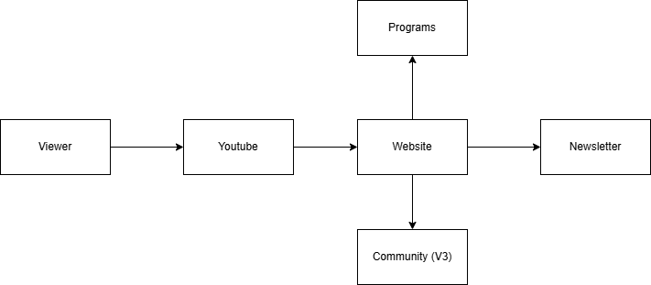
3.2 Frontend Architecture
The frontend is responsible for presenting all user-facing functionality and serves as the primary interaction layer on the platform.
Built Using:
- React
- Vite
- JavaScript
- CSS
Core Responsibilities:
- Website navigation
- Program discovery
- Chatbot interface
- Newsletter signup
- Responsive layouts
- User interaction tracking
- Mobile Accessibility
The frontend follows a component-based architecture where reusable components are separated from page-level functionality. This approach improves maintainability while reducing code duplication throughout the platform.
Major Pages
- Home
- Systems
- About
- Community (Future Expansion)
- Individual Program Pages

Figure 2: Website Navigation
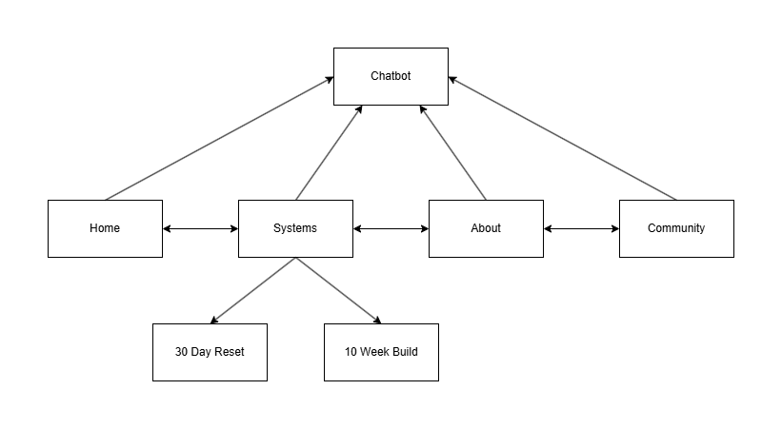
3.3 Backend Architecture
The backend works as the central processing layer for the platform.
Built Using:
- Node.js
- Express.js
Core Responsibilities:
- Chatbot request handling
- Analytics event collection
- Newsletter processing
- API management
- Future community functionality
The backend uses a modular routing architecture that separates concerns amongst endpoints, controllers, middleware, and external integrations. Chat requests are processed through their own dedicated routes and controllers before being sent to the AI layer.
A dedicated health endpoint is also implemented for monitoring backend availability.

3.4 Artificial Intelligence System
One of the platform's primary features is the AI assistant "Bands" AKA the stickman all throughout the social media.
Bands was intentionally designed to function as a website guide rather than a personal coach, due to future systems being held future responsibilities for that.
Design Goals
- Explain website features
- Help users navigate the platform
- Describe available systems
- Explain YouTube content
- Introducing the Improving JB ecosystem
- Give information about JB himself
The AI system uses contextual prompting to determine which knowledge source should be used when generating responses. Different prompt sets exist for:
- Website Information
- Systems & Programs
- YouTube Content
- About JB
- Community Features
This structure improves response accuracy while preventing the assistant from providing information outside its intended scope.
Figure 3: Chat Flow
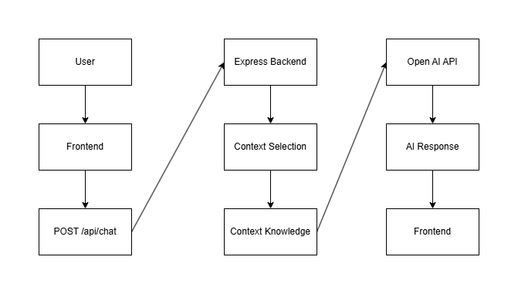

3.5 Analytics Architecture
The analytics system was implemented to better understand user behavior and measure the effectiveness of the platform.
Primary Events Tracked:
- Page Views
- System Views
- User Navigation Patterns
- Future Conversion Events
The analytics infrastructure provides insight into how visitors move throughout the platform and which content generates the highest engagement. Used to influence future videos and versions of the website.

3.6 Newsletter Infrastructure
The newsletter system serves as the primary audience ownership mechanism within the platform.
Its responsibilities include:
- Email collection
- Subscriber management
- Future campaign distribution
- Program delivery
The system creates a direct communication channel between the platform and users without relying entirely on social media algorithms.

Figure 4: Engagement and Conversion Dataflow
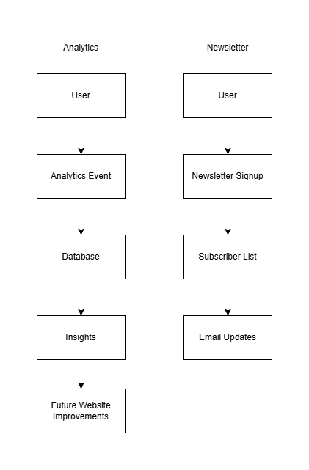

3.7 Security & Reliability
Several measures were implemented to improve stability and reliability.
Request Validation
User inputs are validated before being processed by backend services.
Rate Limiting
The chatbot API includes request rate limiting to reduce abuse and improve system stability.
Environment Configuration
Sensitive credentials and API keys are managed through environment variables rather than hardcoded values.

3.8 Future Architecture Expansion
The architecture was intentionally designed to support future growth.
Planned additions include:
- Community functionality
- Expanded analytics dashboards
- Additional downloadable systems
- Enhanced AI capabilities
This modular architecture allows future services to be integrated without requiring significant changes to the existing platform.

IV. Deployment Progress and Deliverables

4.1 Major Deliverables Completed
Several major components of the Improving JB platform have been successfully developed and deployed.

Completed Deliverables:
• Responsive multi-page website
• Home, Systems, About, and Community pages
• AI-powered chatbot ("Bands")
• Social media link integration
• Mobile optimization
• Backend API infrastructure
• Analytics tracking foundation
• Newsletter infrastructure
• 30 Day Reset system
• The 10 Week Build program
These deliverables establish the core ecosystem of the platform and provide a foundation for future expansion. The current architecture supports additional systems, analytics improvements, and newsletter functionality without requiring significant changes to the current website version.

4.2 Version 2 Development Timeline

Work on V2 of the Improving JB ecosystem began May 10th
Feature | When completed
Newsletter / email capture | 5/14/2026
Updated Flow and Design | 5/17/2026
Updated Chatbot | 5/20/2026
Analytics | 5/24/2026
10 Week Build | ?
Documentation | ?
Table 1: V2 roadmap
(left off here)

